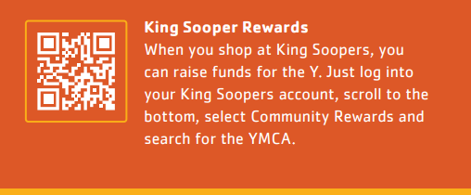

Link your King Soopers Account:

1. Sign in to your digital account.

2. Select Community Rewards

3. Enter “YMCA of Northern Colorado” or the NPO number “TI268”

4. Select and click “Save”.

The YMCA of Northern Colorado will display as your selected nonprofit in the King Soopers Community Rewards section of your account.

If you need to review how much King Soopers has donated based on your spending, you can always do so under your Account details>Community Rewards>Donation Summary.

