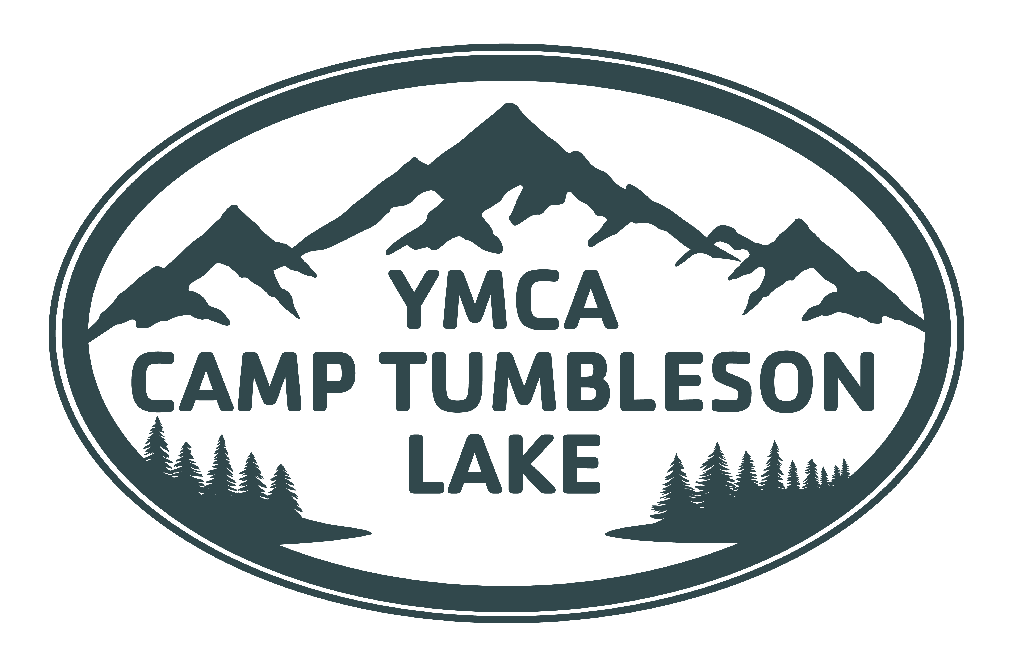

FAMILY CAMP PACKING LIST
Welcome to Family Camp at YMCA Camp Tumbleson Lake! Mountain weather can change quickly, and nights at camp can get chilly even when the days are warm. We strongly recommend packing in layers and bringing plenty of warm bedding so your whole family stays comfortable.
CLOTHING
- Underwear + socks for each day, plus extras
- Comfortable pants for hiking and camp activities
- Shorts
- T-shirts
- Long-sleeve shirts
- Warm sweater, fleece or pullover
- Warm jacket
- Warm pajamas or base layers
- Bathing suits
- Rain jacket
- Sneakers or other sturdy, closed-toed shoes
- Hiking shoes or boots, if desired
- Camp shoes or sandals with a back
- Shower shoes/flip flops
- Hat with a brim for sun protection
- Sunglasses!
- Warm hat/beanie for mornings and evenings
- Warm socks for sleeping
- Gloves, especially for anyone who gets cold easily
TOILETRIES
- Toiletry bag or carrying case
- Soap, shampoo + conditioner
- Toothbrush + toothpaste
- Brush or comb
- Deodorant
- Towels (we recommend one for showering and one for the lake)
- Sunscreen (SPF 50+ recommended)
- Insect repellent
- Lip balm (with SPF!)
- Moisturizer
- Menstrual products, if needed
- Any personal medications
BEDDING (PACK WARM!)
Family Camp lodging can get a bit chilly overnight. Please bring more bedding than you think you'll need!
For each family member:
- Warm sleeping bag or warm blacket
- 1–2 additional warm blankets
- Pillow(s)
- Twin-size fitted or flat sheet (if using sheet set instead of sleeping bag).
CAMP GEAR
- Reusable water bottle for each family member
- Backpack/daypack
- Flashlight or headlamp
- Extra batteries
- Sunglasses
- Small bag for carrying waterfront gear
- Reusable wet bag/plastic bag for wet swimsuits and towels
- Camp chairs, if desired
- Books, cards or simple family games for downtime
- Camera, if desired
OPTIONAL FAMILY COMFORT ITEMS
Family Camp is your family's getaway, so feel free to bring a few things that make your stay more comfortable!
- Extra pillows and blankets
- Earplugs
- Portable crib/Pack 'n Play for little ones, if needed
- Small battery/rechargeable fan
- Travel mug for coffee or tea
- Laundry bag for dirty clothes
PLEASE LEAVE AT HOME
- Weapons or knives
- Fireworks
- Illegal drugs
- Smoking products
- Expensive or irreplaceable valuables
A NOTE ABOUT MOUNTAIN WEATHER
Camp Tumbleson Lake sits high in the Colorado mountains, where sunny afternoons can turn into cool evenings quickly. Pack for warm days, rain and cold nights. Layers are your best friend! When in doubt: bring the extra blanket. The tents will have gas buddy heaters available.

Please practice the core value of Responsibility by keeping track of your belongings during Family Camp. YMCA Camp Tumbleson Lake is not responsible for lost, stolen, or damaged personal items.

